**Getting Started**

**An introduction**…

It does not matter if you are 5, or 50 years old... Once the fishing bug has sunk its teeth into you, your life will change forever, and for the better.

Days will be spent next to the ocean, on the hunt for a fresh Galjoen of Kob.

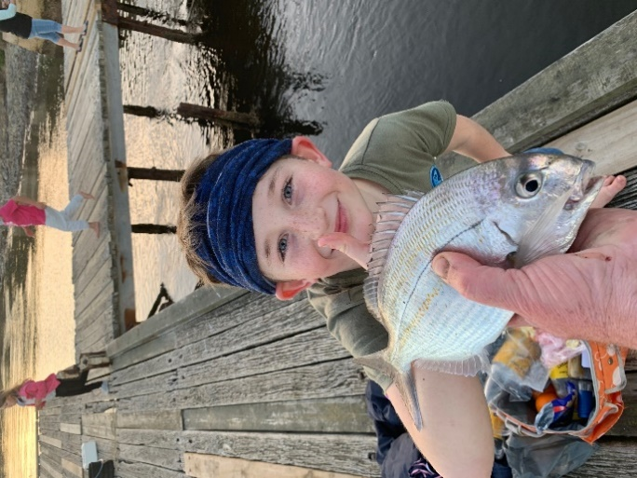At night, you will lie awake, trying to figure out new techniques and spots in your head.

Hours will be spend going through books, and pics on Google.

YouTube will become your new “best friend” and any Fishing Tackle shop, might become synonymous with a bottomless pit, where you might be wasting your hard earned cash on fishing tackle you might not need.

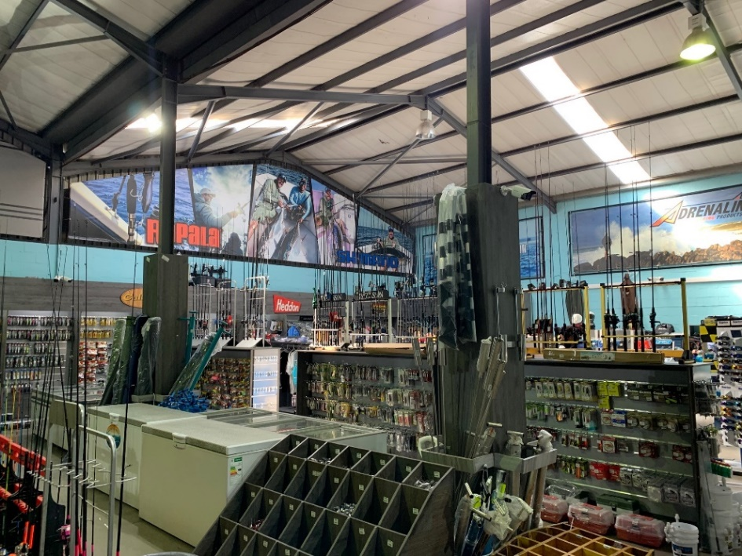That’s why it is imperative to find a local, trustworthy tackle shop- with friendly and knowledgeable staff that will assist you with what you really need, instead of another hasty sale.

A great starting point would be to identify the type of Saltwater Fishing you and your youngster would enjoy the most, and which would give you the most rewarding experience.

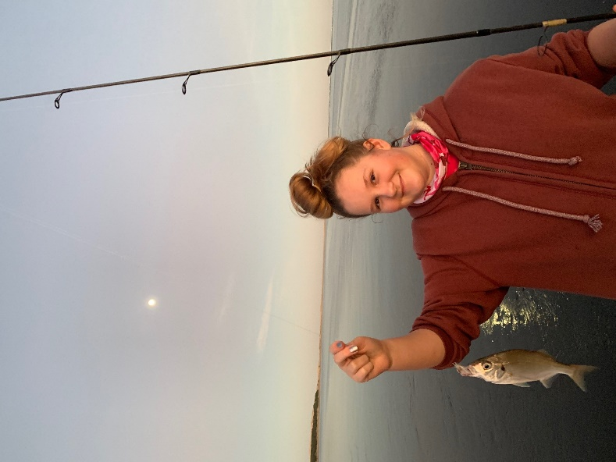As a novice, you basically have a choice between **estuaries, lagoon and light tackle fishing- rock and surf (beach) fishing,** or just merely throwing small baits in harbors, looking for Mullett, blacktail or Strepies.

***“The Harbors, rock pools and estuaries would absolutely be the most ideal area for any novice to start out with, for a few simple reasons.”***

Harbors and estuaries normally have juvenile fish in abundance, which would allow you to really hone your skills in a safe and fun environment, where the whole family can enjoy the outdoors.

Also, it is mostly a visual type of fishing, with the angler being able to see the fish, and it taking the bait. Another important factor would be that the start-up tackle is relatively inexpensive, allowing you to experiment with different setups on different size fish species.

**Fishing rods**

The ideal setup for starting out in these areas would be a light spinning fishing rod, of between 5 to 7 foot, and able to comfortable flick a light bait and small sinker far enough.

This will allow for extremely light tackle fishing, and would even be able to handle the odd surprise catch that normally leaves the inexperienced youngster with a broken trace and nightmares of “the one that got away”, at an early age. It’s not necessary to purchase the most expensive fishing rods from the outset, but rather ask the shop assistant to guide you in purchasing a solid “entry level” fishing rod, that can handle being dropped and knocked against rocks and walls.

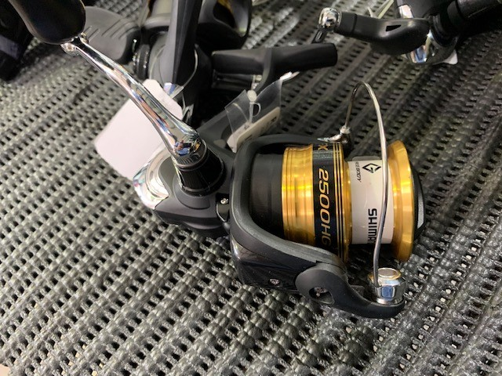**Fishing Reels**

It is my opinion that the best reel for a junior angler, would be the “coffee grinder’ style reels.

The evolution in the development of these reels, has rightfully been branded as the “grinder revolution”.

These reels are extremely user friendly, and durable to easily withstand the knocks and scrapes it would inevitably get, while being dunked and dragged around on a concrete jetty or harbor wall.

**“the more you fish, the luckier**

**you seem to get”**

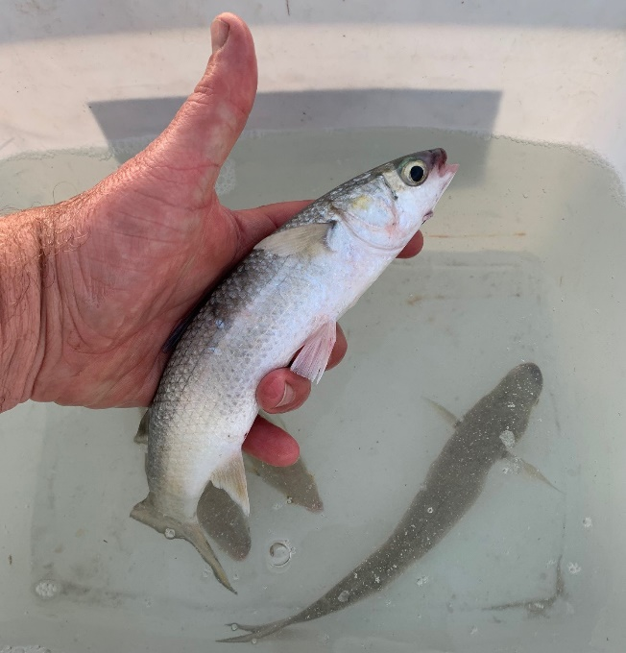

All you would need, would be a small, compact reel, with decent line or braid capacity that would not “break the bank” should it need replacing or servicing.

*“Again, this is where it is so important to have a knowledgeable tackle store that would cater for the novice angler, as well as the more experienced individual*.”

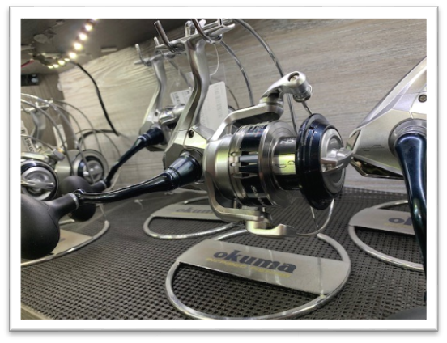**Fishing lines**

Here we have a choice of either braided fishing lines, or monofilament lines, with both having advantages.

Braid gives you sensitivity that you do not get with monofilament lines, yet, “mono” remains a cheaper option, with less hassles for the newcomer to the sport.

Braided lines would require 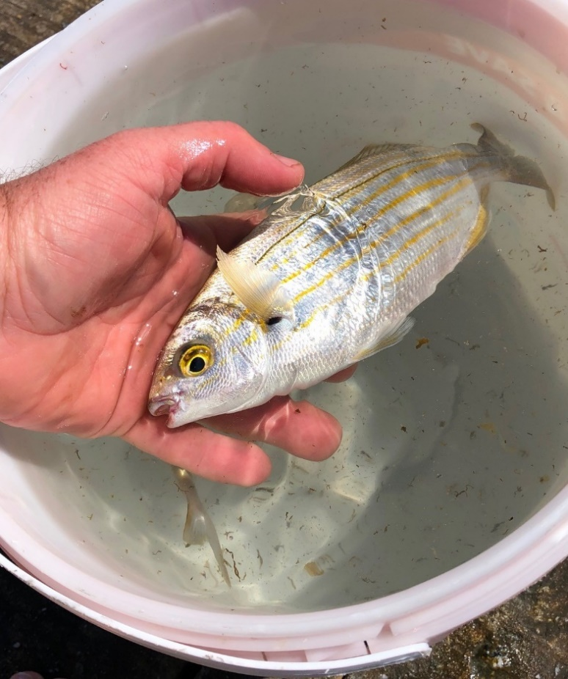specialized knots to attach leaders and swivels, were “mono” line can be fished straight onto the swivel.

***Fishing in harbors and rock pools are all about catching as many fish as possible, in the shortest amount of time. It’s about having fun!***

So, depending on the age and level of experience, any great quality monofilament line would be perfect.

**Hooks and sinkers**

The main target species in and around harbours and jetties, would be mullet, Strepies (karenteen), Blacktail and klipvis (rockfish).

Hook sizes would be dictated largely by the sizes of the fish being targeted, and on average, a small hook size, for example a #3 and even down to a #6 would be just fine.

Also, use smaller swivels, (#8), and light ball or barrel sinkers to get the setup to match perfectly.

The main object with harbor and estuary fishing is to have fun, while fine-tuning your skills for when you hook into a surprise catch!

**Bait**

This is one form of fishing where “anything goes”. Sardine, squid and white mussel can all be sourced at the local tackle shop, and would attract anything you would find swimming in a harbor or under a jetty.

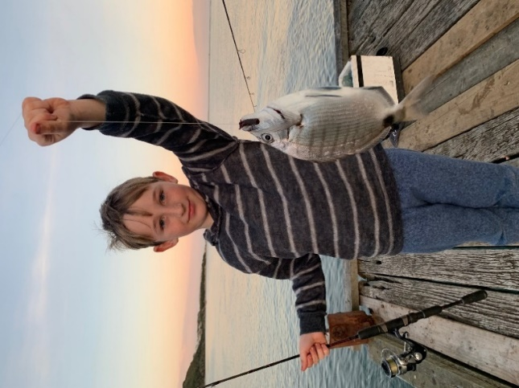Fine strips of squid and white mussel will stay on the hook easy, and a messy sardine bait will keep the kids occupied for a long time! Use thin elastic latex cotton to secure the bait to the hook, to prevent the fish from stripping the hooks in seconds.

**Chumming** is a sure way to get fish attracted to the area you are fishing.

Keep old bait stored in the freezer, then, at the fishing spot, cut it into small pieces and mush it up.

Simply throw the chum into your fishing area and you will be amazed how much fish a kg of old bait can attract to your spot! Keep it going every 10 minutes or so, to keep the fish interested.

*The Golden Hour…*

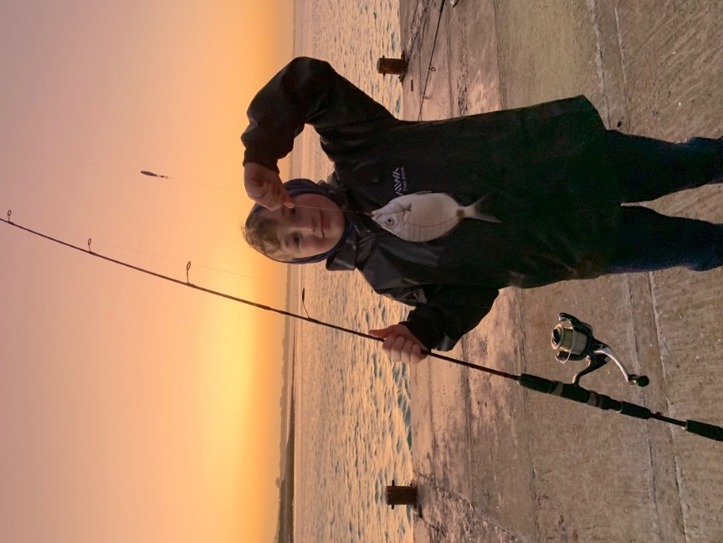**“Junior anglers, especially kids of a younger age needs “instant gratification”, to keep them interested and eventually hooked on fishing.**

**Do some research on safe and productive spots in your area, and enjoy the experience.Fishing is so much more than just trying to catch the biggest or most fish. It is a tool that will teach your child the importance of having respect for nature.”**

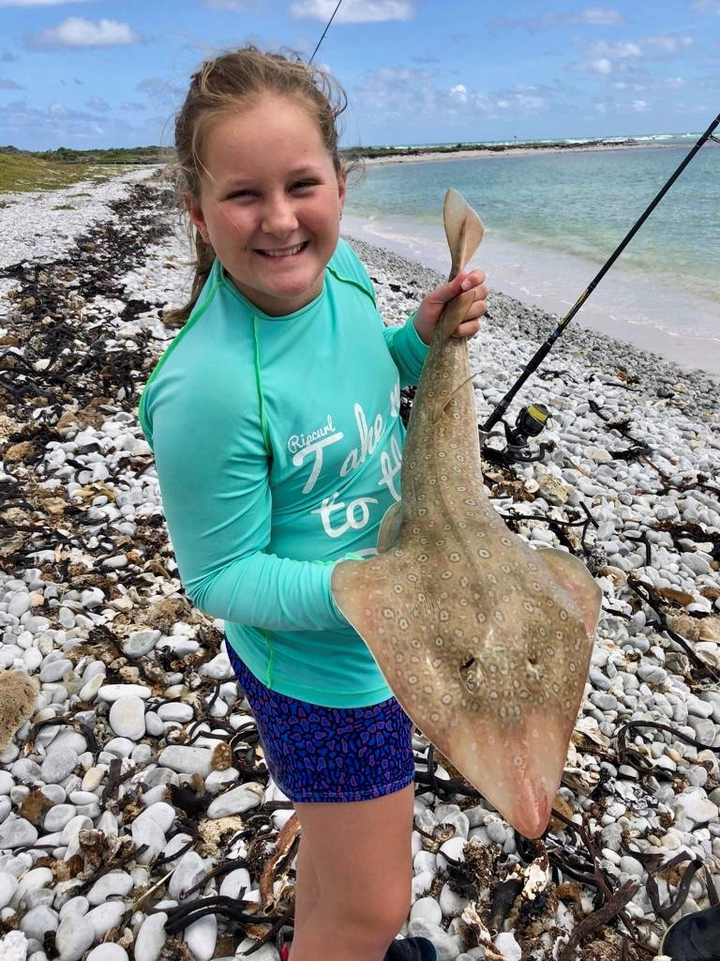

***Leah with a Lesser Sandshark, caught on a sardine bait in knee deep water-safely released.***

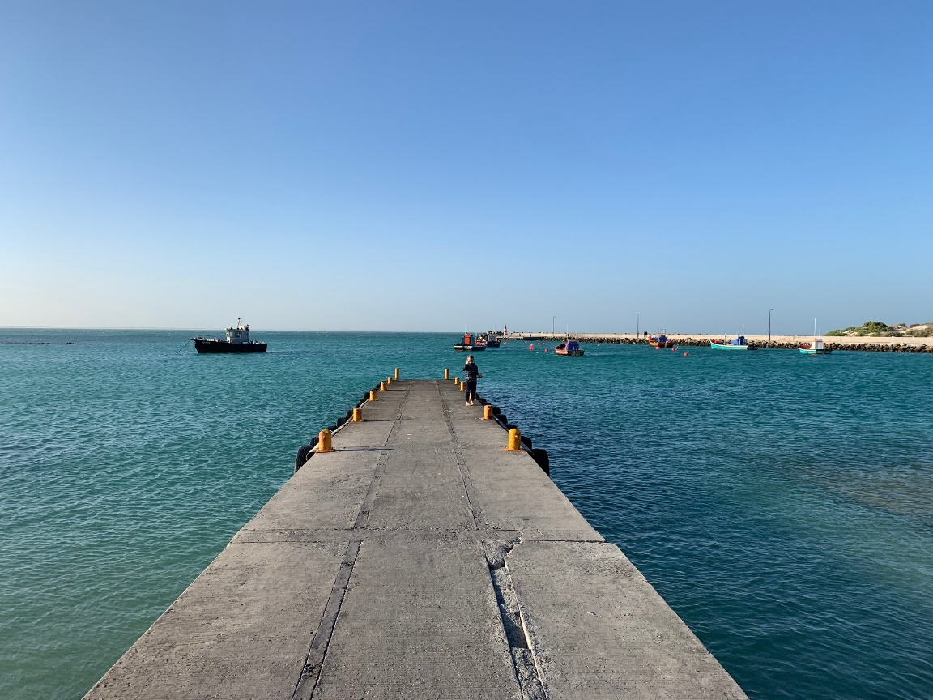“To experience nature at its fullest, and learning how every tide, change in wind direction and even the time of day, has an effect on fish behaviour, and so, notice the little nuances in nature, that sadly goes by unnoticed every day.”

“the world needs less x-boxes, and more tackle boxes”….

**\*\*\***

**Leah with a**